**Explosion Particles and SFX**

**Objective**: Creating a simple explosion that will trigger some particles and also add a sound effect.

Warnings: If we have any warnings in our console we’re going to clear them up. They might be caused by scripts that we’re not using so let’s just delete them.

1. Lets rename our cube that we placed under the ship to **Landing Pad** and make it into a prefab.

**Particle System Component**

|  |  |  |
| --- | --- | --- |
| Particles |  | Particle System is a Component added to a Game Object |
| We use Modules for controlling behavior |
| Emitter |  | Each particle is not a Game Object |

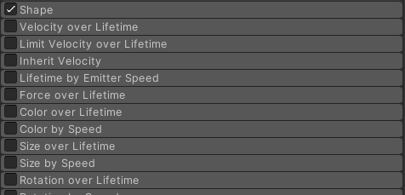The Particle System is a component that we add to a game object. We have the emitter, we have particles, and we use modules for controlling the behavior. So modules are, if we go to our ship where we have the bullets here, all these gray things, these tabs down here, these are modules. And it's important at this point for us to be really clear that each particle is not a game object. And the entire particle system is not a game object, it's a component that's added to a game object. he particle system is created to be super efficient. And so, it can push around thousands of things on this screen and not have our system come to a halt.

RECAP: PARTCILES ARE NOT GAME OBJECTS

1. Create an **Empty Game Object** and call it **Explosion**. Finally lets add a **Particle System component** to this game object**.**

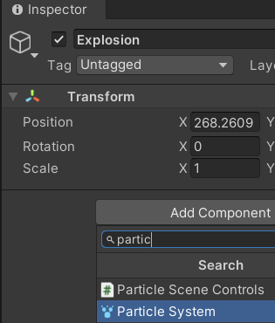

1. Im also going to create an **Audio Source** component to this Explosion game object.